Experiment1:
Write a program to find area of geometrical figures using method.
Aim: To write a Java program that calculates the area of different geometrical figures (Square, Rectangle, and Triangle) using methods.
Program:
import java.util.Scanner;
class AreaCalculator {
static double areaOfSquare(double side) {
return side * side;
}
static double areaOfRectangle(double length, double breadth) {
return length * breadth;
}
static double areaOfTriangle(double base, double height) {
return 0.5 * base * height;
}
public static void main(String[] args) {
Scanner sc = new Scanner(System.in);
System.out.println("1. Square\n2. Rectangle\n3. Triangle");
System.out.print("Enter your choice: ");
int choice = sc.nextInt();
double area = 0;
switch (choice)
case 1:
System.out.print("Enter side of square: ");
double side = sc.nextDouble();
area = areaOfSquare(side);
break;
case 2:
System.out.print("Enter length and breadth of rectangle: ");
double length = sc.nextDouble();
double breadth = sc.nextDouble();
area = areaOfRectangle(length, breadth);
break;
case 3:
System.out.print("Enter base and height of triangle: ");
double base = sc.nextDouble();
double height = sc.nextDouble();
area = areaOfTriangle(base, height);
break;
default:
System.out.println("Invalid choice!");
return;
}
System.out.println("Area = " + area);
}
}

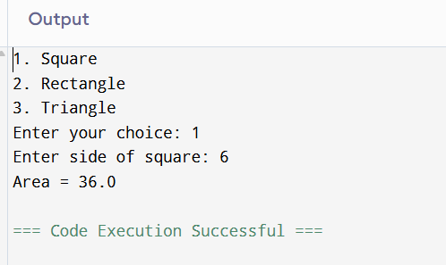

Demonstration 2:
Write a program to generate factorial, Prime, Fibonacci of list of number and
reading input as command line argument.
Aim: To write a Java program to generate factorial, Prime, Fibonacci of list of number and reading input as command line argument.
Program:
import java.util.Scanner;
class Demo2 {
static boolean isPrime(int n) {
if(n <= 1) return false;
for(int i = 2; i < n; i++) {
if(n % i == 0) {
return false;
}
}
return true;
}
static long factorial(int n) {
long fact = 1;
for(int i = 1; i <= n; i++) {
fact *= i;
}
return fact;
}
static void fibonacci(int n) {
System.out.print("Fibonacci series up to " + n + ": ");
int a = 0, b = 1;
while(a <= n) {
System.out.print(a + " ");
int temp = a + b;
a = b;
b = temp;
}
System.out.println();
}
public static void main(String[] args) {
Scanner sc = new Scanner(System.in);
System.out.print("Enter a number: ");
int num = sc.nextInt();
if(isPrime(num))
System.out.println(num + " is a Prime number");
else
System.out.println(num + " is NOT a Prime number");
System.out.println("Factorial of " + num + " is: " + factorial(num));
fibonacci(num);
}
}

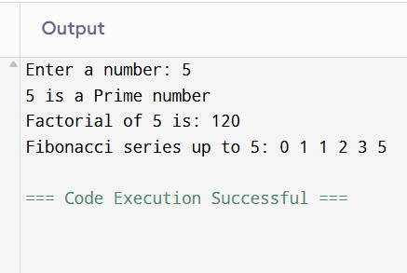

Demonstration 3
Design a class to represent a bank account include the following members:
Aim: Account Number, Name of the Depositor, Balance amount, to assign initial values To deposit an amount, To withdraw an amount after checking balance, To display the details.
Program:
class BankAccount {
private String accountNumber;
private String depositorName;
private double balance;

BankAccount(String accountNumber, String depositorName, double balance) {
this.accountNumber = accountNumber;
this.depositorName = depositorName;
this.balance = balance;
}

void deposit(double amount) {
balance += amount;
System.out.println("Amount Deposited: " + amount);
}

void withdraw(double amount) {
if(balance >= amount) {
balance -= amount;
System.out.println("Amount Withdrawn: " + amount);
} else {
System.out.println("Insufficient Balance");
}
}

void display() {
System.out.println("Account Number: " + accountNumber);
System.out.println("Depositor Name: " + depositorName);
System.out.println("Balance: " + balance);
}

public static void main(String[] args) {
BankAccount b = new BankAccount("12345", "Anu", 5000.0);
b.display();
b.deposit(1500);
b.withdraw(3000);
b.display();
}
}
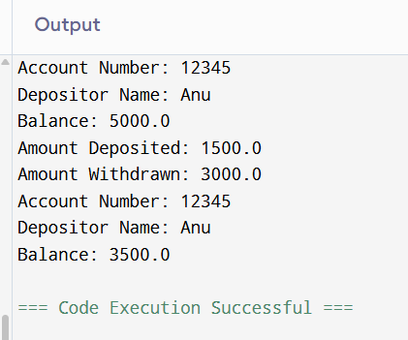

Demonstration 4:
Write a program to implement Methods, and Constructor concepts using OOP Java
Aim: To implement Methods, and Constructor concepts using OOP Java.
Program:
class Student {
String name;
int age;

Student() {
name = "Unknown";
age = 0;
}

Student(String n, int a) {
name = n;
age = a;
}

void display() {
System.out.println("Name: " + name + ", Age: " + age);
}

public static void main(String[] args) {
Student s1 = new Student();
Student s2 = new Student("Anu", 25);
s1.display();
s2.display();
}
}

